Report:

This report I will try to explain according to the **Business Intelligence and Data Engineer** Lifecycle.

* As a Business Intelligence and Data Engineer working for the Organization, I collaborated with the business users and gathered the requirements.

Initially, the data I got from the organization are  
**user_activity_data:** The data consists of user_activity on the platform and has columns like user_id, session_id, session_length, message_sent, feedback_rating, resources_clicked

**recommendation_data:** The data contain recommendations_data and has columns like recommendation_id, recommendation_type, click_through_rate, feedback_score

**moderator_performance_data:** The data contains moderators_data and contains columns like moderator_id, chat_sessions_moderated, avg_response_time, user_satisfaction_score

* As the next step, I would like to understand the data by plotting visualizations in matplotlib, seaborn using Python.

There are a lot of visualizations in the Jupyter notebook, to avoid congestion and keeping concise I’m listing only impactful visualizations.

**Distribution of session_length:**

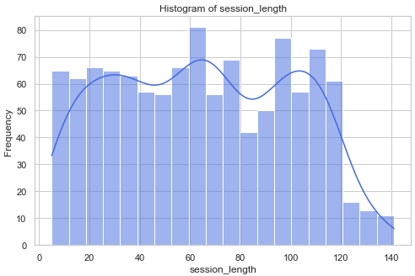

It's almost having the similar distribution for all of session length's. It means the users maintained between 10 to 120 minutes in the app.

**Distribution of messages_Sent:**

Most users sent between 10 to 40 messages per session.

**Distribution of feedback_rating:**

Users given feedback between 1 to 6 where most of the users given 5(28.7%).

**Distribution of resources_clicked:**

It has almost the uniform distribution where users clicked between 1 to 4 resources.

**Distribution of recommendation_type:**

Even the recommendations are uniform where Podcast's are more recommended for users compared to Video and blog.

**Coming to the User engagement analysis:**

This is the plot between messages_Sent vs session_length based on the feeback_rating. Generally, the users who spent more time on the app should interact with the platform more and send more messages.

But we can clearly observe that, there are users who spent more time on platform passively and give very less feedback_rating.

And there are users who spent less time on app and give more feedback. This feedback is lightly misunderstood. We need to deep dive more to create more features.

Distribution of average_feeback_rating and session_length in buckets:

This the average aggregated data across session_length bins.

**Coming to the Recommendation analysis:**

I have analyzed the various recommendation_type and its engagement

This picture clearly states that users are engaged with video type compared to blog and podcast.

On the other hand, the feeback_Score for these recommendations are

It shows the uniform distribution of feedback_Score among the recommendations with podcast is slightly less.

**Coming to the moderator performance analysis**

Generally, it would be like if the moderator responds to the user in the very less time, he should be given more satisfaction_score. Here it is complete viceversa.

It can be due to the moderator may not satisfied the user or he is closing the requests soon.

It is clearly stated that, if the moderator is responding late, he is getting less user_Satisfaction_Score.

**Joining the data:**

1. Joining all the tables is the difficult thing as we didn’t have the similar joining key in the tables.
2. Firstly, I have joined **users table** and the **recommendations table** based on the user_id primary key.
3. Now, the challenge is joining the **user_recommendation table** and the moderator table. To tackle this challenge, I have followed the proportional approach based on the idea where one moderator can assist different users.
4. So, we can generate moderators **by (chat_moderators_managed/total moderated_sessions)*100.**
5. Now we have list of moderators and we are joining them with the **users_recommendation** table.

**Sample of final data**



Still there are few issues after the joins,

After joining the data, I found a lot of missing joins for recommendations table. Its 606 users, if there is less missing join rate, we can be able to provide better platform for user satisfaction.

Coming to the metrics,

To define the engagement or effectiveness across these datasets, I have defined three metrics. They are calculated per user and listed below.

1. **Engagement Score:** This metric is used to calculate engagement score by giving importance to session length and message length and giving importance to feedback rating. It is calculated as follows.

*Engagement score = (session_length/max_session_length)*0.4 + (messages_sent/max_messages_sent)*0.4 + (feedback_rating/max_feedback_rating)*0.2*

Here, the metric is used to evaluate user participation and satisfaction.

1. **Responsiveness Efficiency:** This metric is used to calclulate responsiveness efficieny by dividing avg_reponse_time and user_satisfaction_score. Finally diving by 5 to normalize it.

Responsiveness Efficiency = (1/(avg_response_time+1))x(user_satisfaction_Score/5)

1. **Recommendation Conversion Rate (RCR):** This metric is used to calculate the engaged recommendations per total users who received recommendations. The engaged recommendations are someone who has click_through_rate>0 and feedback_score> median_feedback_Score to ensure that feedback_score is not randomly given.

RCR = (engaged_users/total_recommendation_users)x100

This metric meaningful user engagement with recommendations by focusing on both click-through rates and feedback quality.

I have created a separate python script to create the metrics based on the data. It should be run after the data cleaning script.

**Sample metrics image:**

